**Project Design Phase-II**

**Data Flow Diagram &User Stories**

|  |  |
| --- | --- |
| Date | 30 October 2022 |
| Team ID | PNT2022TMID29092 |
| Project Name | A Gesture-based Tool for Sterile Browsing of Radiology Image |
| Maximum Marks | 4 Marks |

**Data Flow Diagrams:**

A Data Flow Diagram (DFD) is a traditional visual representation of the information flows within a system. A neat and clear DFD can depict the right amount of the system requirement graphically. It shows how data enters and leaves the system, what changes the information, and where data is stored.

**Simplified:**

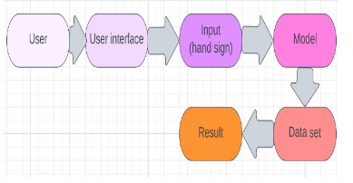

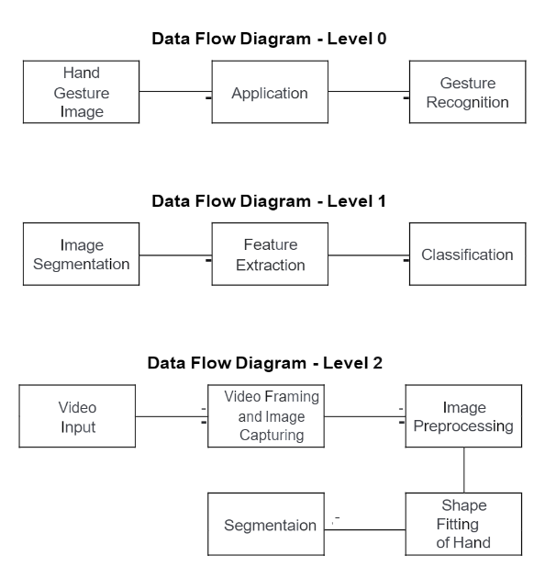

**User Stories**

Use the below template to list all the user stories for the product.

| **User Type** | **Functional Requirement (Epic)** | **User Story Number** | **User Story / Task** | **Acceptance criteria** | **Priority** | **Release** |
| --- | --- | --- | --- | --- | --- | --- |
| Customer [Doctor/Surgeon]  (Web user) | Launch | USN-1 | As a user I can launch the webpage to upload and manipulate the scan images | I can access the webpage | High | Sprint-4 |
|  |  | USN-2 | As a user I can use different web browsers | I can access the webpage using different web browsers | High | Sprint-1 |
| Administrator | IBM Cloud | USN-1 | Access the database | Database Management | High | Sprint-3 |
|  |  | USN-2 | Server crash, database recovery | Resolve the errors/ issue, recover the lost data from database | High | Sprint-5 |
| Customer care executive | Availability | USN-1 | Interpret and recognize gesture inaccurately | Webcam detection | Medium | Sprint-5 |
|  |  | USN-2 | When the website is unresponsive or an internal error occurs in the website | Webpage is unresponsive | Medium | Sprint-4 |